Jakub Zarębski

M00507447

CSd2550

DropBox

Spis treści

1. Introduction 1

1.1 To the Module

1.2 To the Task

2. Related work 2

2.1 Related websites and applications

3. Requirements 3

3.1 Basic requirements

3.2 Advanced requirements

4. Design 4

4.1 Sketches

4.2 In-progress overview

5. Implementation 8

6. Testing 9

6.1 Basic website testing

7. Journal 10

7.1 Week 1

7.2 Week 2

7.3 Week 3

7.4 Week 4

7.5 Week 5

7.6 Week 6

7.7 Week 7

8. Conclusion & Future work 13

9. References 14

## Introduction

* 1. To the Module

The CSD2550 module is about development of the web-based application such as websites and the databases to support it. We are learning the bases knowledge of programming in web-orientated languages like html, javascript and more database driven PHP, MySQL.

* 1. To the Task

The first term task is to design, build and test the remote Web space management system like drop box or google drive. Suitable for handling web site content of various types. Allowing user to store data external on server, organize their files, rename them , delete them , download. Each user have own space dedicate to them guarded by password requirement . Also the this system allows to access database from any computer connect to the web , no just local from user computer.

## Related work

2.1 Related websites and applications

Most related websites is of course dropbox website which is one

of most popular in this field, next one is google drive with different subsection for videos and photo (picasa album) and next can be one drive from Microsoft which is used by Middlesex University tied well into office – windows environment makes it for me very good combination with google drive for my personal files and One drive for school related. One drive is default installed into Windows 10/8.1 which is for one people unnecessary for others can be introduction into cloud-based storage and quick files exchange. It also takes extra work from companies working on the windows systems.

Google drive is in my opinion better for personal storage as in my case I using the android powered smartphone, it sync files that I want use on my phone and vice-versa. For iOS users iCloud do similar thing and one-drive to some extend for Windows Phone users.

Related can also be any forums , which in most cases support uploading pictures, basic files exchange and of course it is secured by password/login barrier. There are also a file exchange websites often free with extra paid content and features such as megaupload, mediafire etc. This can also applied to the Facebook groups, they works on similar terms, especially the closed ones, the selected amount of people can share the files the from pictures to videos.

## Requirements

* 1. Basic requirements

My program should be written as PHP scripts . The user should be

able to work with this program via a Web browser from any computer

connected to the Internet. When the user launch website with dropbox he can login in using password and login/e-mail stored in database on server, without this he cannot access into storage area. Aside of login user can create new account using e-mail and password, also he can reset it if forget by using set e-mail. Once logged in system user can view his files, upload new ones , delete old ones , make and delete directories. User’s space should be limited, all this should be stored on server. For website it should be combination of html, css, javascript and php. For design and interface we have free hand but the look and gui should be easy to get for any user and not resource-heavy in term of visuals.

* 1. Advance requirements

Different interface depends on who is logged in, feature allowing to

create shared space for set numbers of files, granted access to selected users. Action bar for any action that user can performed. New action like sorting files by e.g. file name or upload date. Adding new categories for files and organized them, e.g. put photos in whole new space independent from their place in folder, to get better view of set type of files. Search option in whole database, folder, categories. User statists and last activity displaying e.g. what files are new, how many files are in this user’s space etc.

## Design

* 1. Sketches

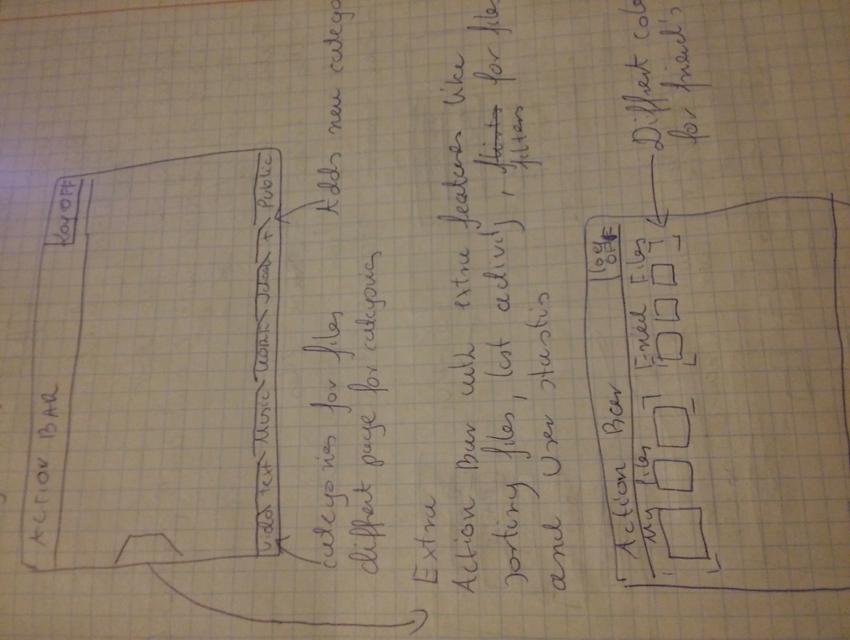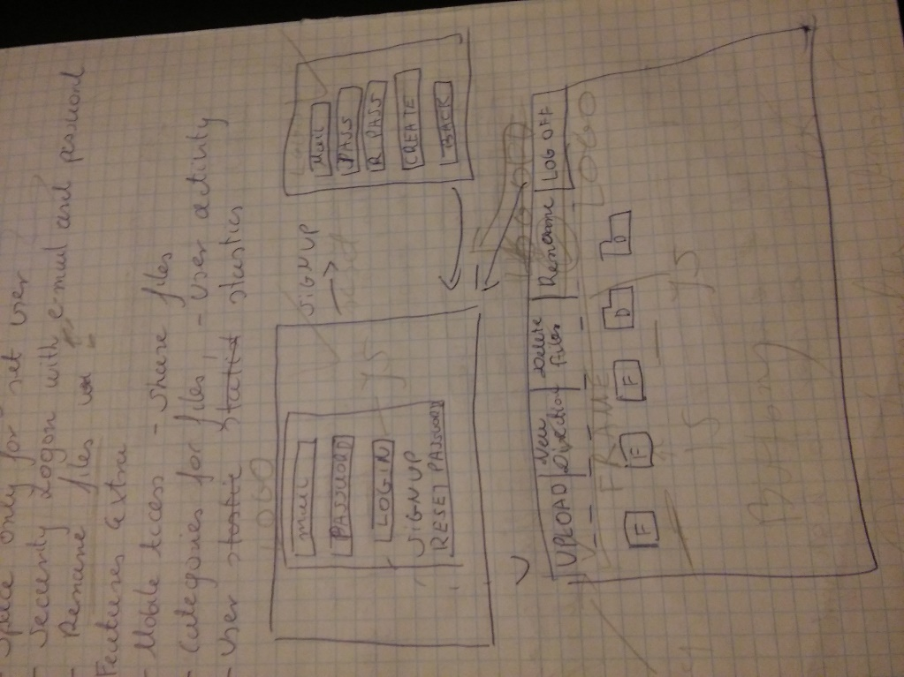

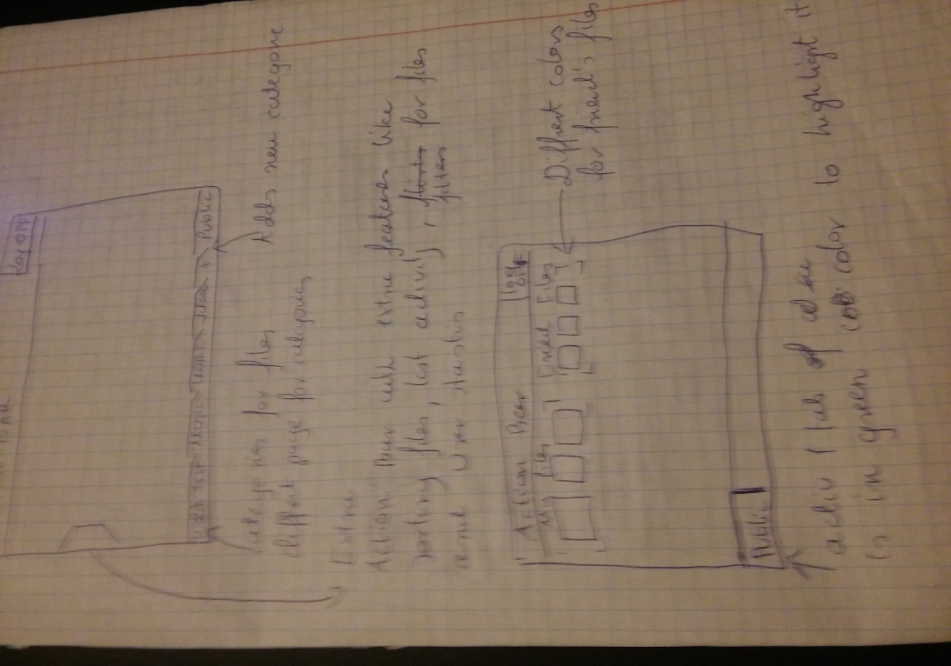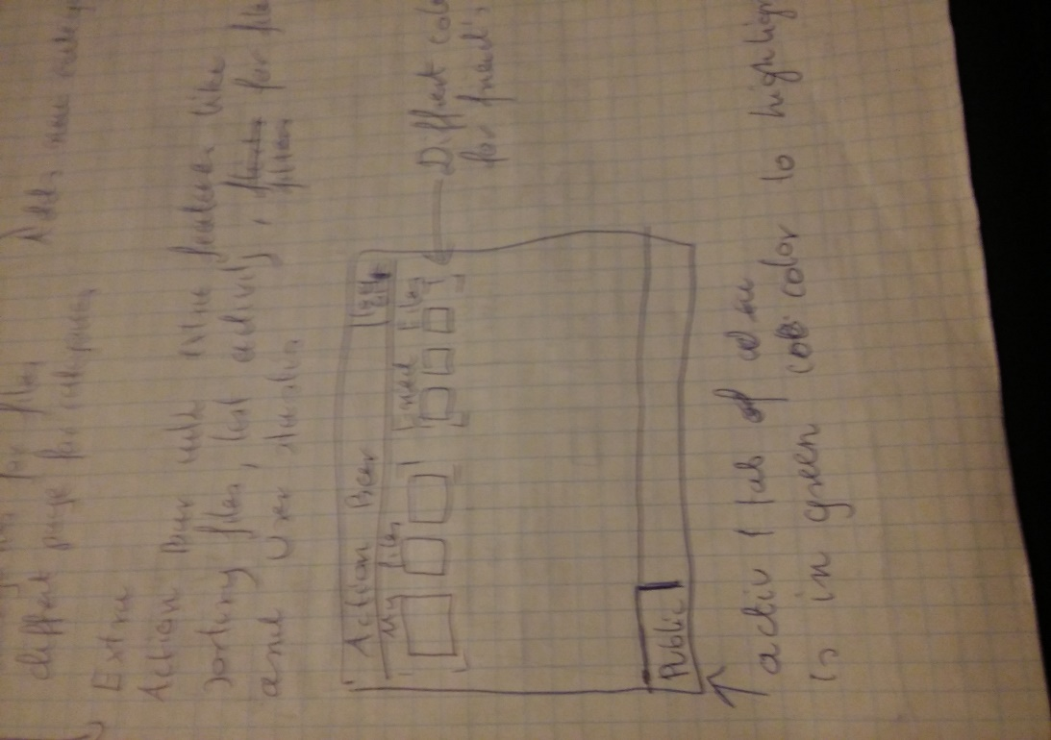

* 1. In-progress overview

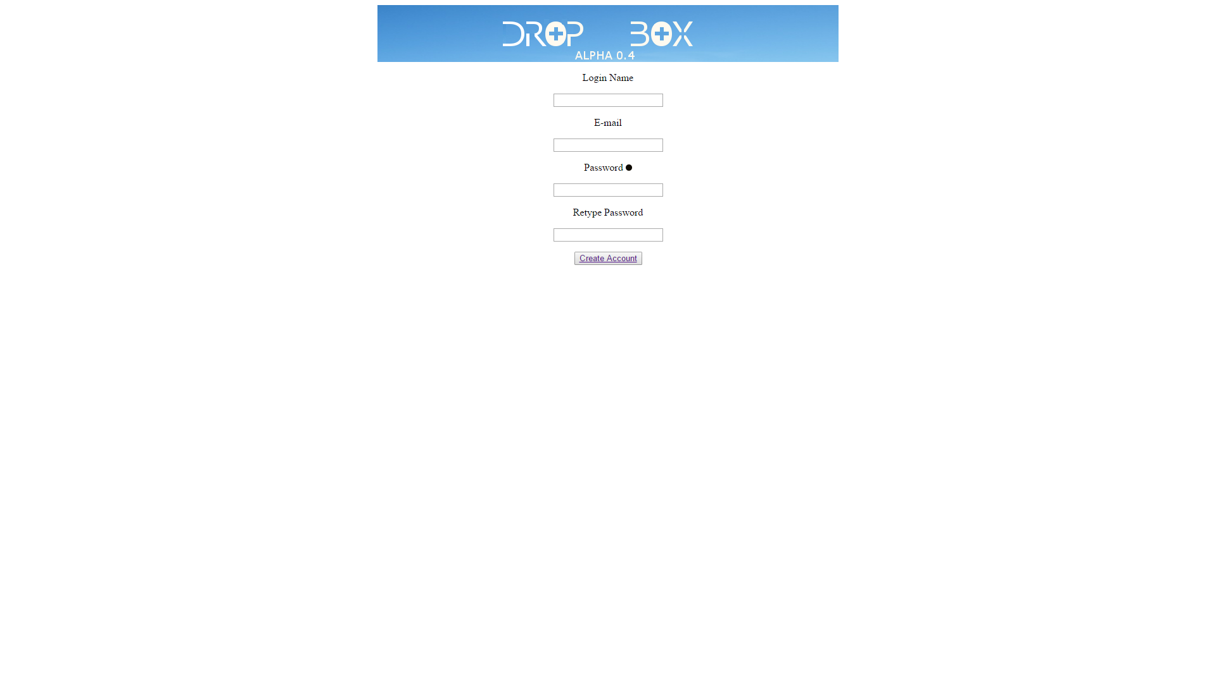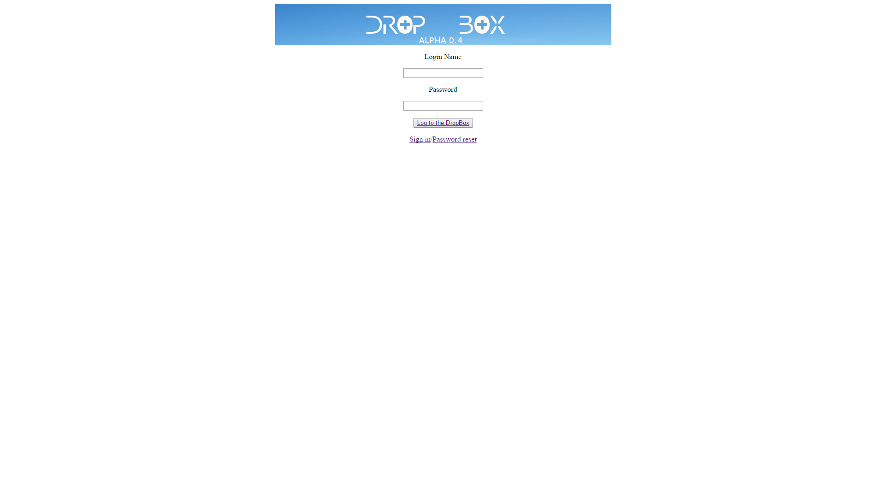

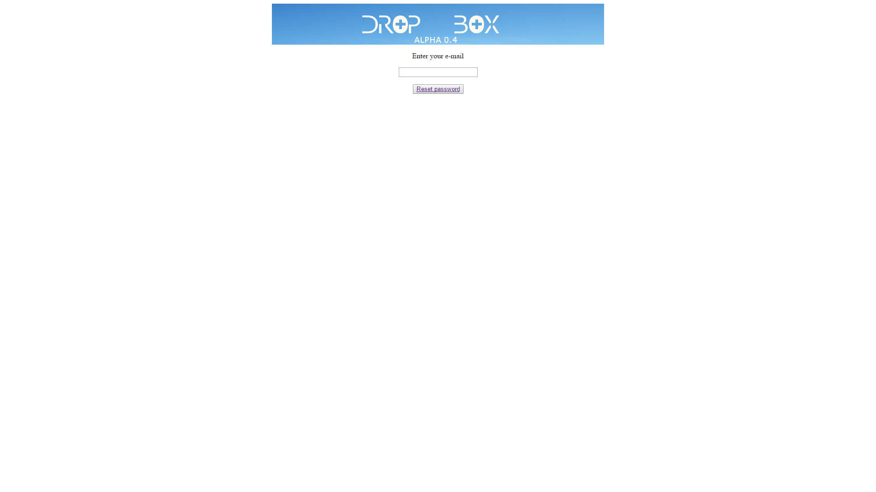

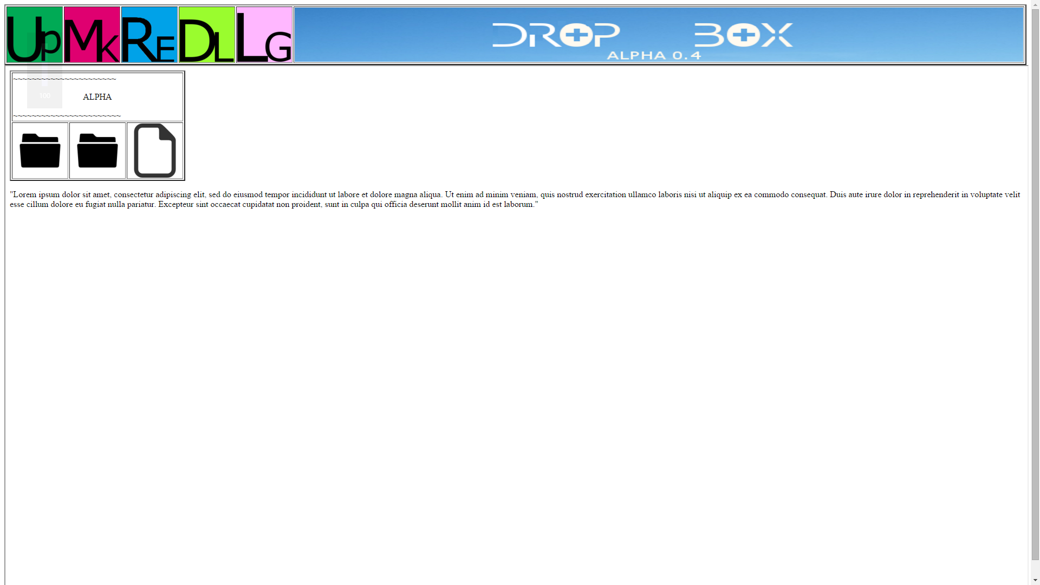

## Implementation

* 1. - - - > to be continued < - - -

## Testing

* 1. Basic website testing

After basic coding of web in html, I tried all buttons if they works and there is one interesting thing about coding hyperlinks into button <button><a href…> works just fine in chrome but it doesn’t work in firefox when I switch them to <a href><button> it start to work fine in firefox and Edge. I also check if return option - > click on logo < - is working properly and that didn’t cause any problem in browsers. Also testing button to logging out didn’t cause any issues.

* 1. Java-script testing
  2. Further testing

-> to be continued < -

## Journal

* 1. Week 1 :

It was introduction into basic HTML for me it was more of reminder and learning new things. I have some experience in html coding after my polish high school. We got a new website to learn and keep our progress in web-development [www.codeacademy.com](http://www.codeacademy.com)

Also we were ask to do our sketches for dropbox design and list of features we would like to have in.

* 1. Week 2:

I started to setup basic html into my site using kED 2 editor which is editor for html, css, javascript and xml. It is very helpful, more than standard text editor like notepad because kED shows errors, it has quick look on browser version of your site, you can add most of code from quick menu or create table in very easy way. Other good program I will consider to use later will by Adobe Dreamweaver for it extra feature which can be useful after adding database functions. For Website I set up simply website with button as links to each other’s login page to reset password or to sign up page. The main page is empty right now.

* 1. Week 3:

This was CSS introduction, we progress with code academy course this time with their css section, once again for me it was more reminder than real learning. For my website I don’t plan to use much of CSS styling, just for basic formatting and coloring.

* 1. Week 4:

In this week I focus on visual aspect of basic website. I created logo for my website using Gimp, firstly I download picture of sky from google images (allowed to use freely) then after couple of different concepts I decided to go with simply white Drop Box text on this sky background, after create first version, I didn’t feel that’s best I can get from this concept.

So I decided to go for more modern look with “broken” characters,



And that’s is probably final version of my logo to add more personality in this project.

Logo wasn’t only thing I created in Gimp next one were icons for set actions and probably I will be adding more of them as development progress

.

First one is for DeLete folder (but probably will be DownLoad), next one is UPload, last is MaKe (direction), their colors are set in CSS file.

Main inspiration was design of Microsoft office/outlook style minimalistic but pretty. I also plan to do same type of minimalistic icons for folders and files in dropbox to keep this design.

* 1. Week 5 :

This was more of thinking about project and doing something, for main website I add frame where main content will be display leaving “action” bar with button always on top. The frame is mainly for addition function I want to tried to do that is tab for files categories such as videos tab or photos tab, when user click on tab it will just refresh tab with right content and files. And the active tab will changed color to green using CSS.

* 1. Week 6 :

In this week I look into javascript but is yet to be implement into my side , I wanted to have right look on this matter to what things I need javascript etc. Firstly it must check if user enter something into login/email section on login page if not the it will not allowed to enter site (of course without checking if this password in database). Similar thing is with sign up / reset pages the button and prompt up will be up only if user enter something into textboxes.

* 1. Week 7 :

PHP. - > to be continued < -

## Conclusion & Future work

> to be continued < -

## References